DECODELABS: DATA ANALYTICS INTERNSHIP

Project 1: Data Cleaning & Preparation

Change Log Report

Intern Name: Chisom Promise Onyekaba

Date Submitted: 30th May 2026

Dataset: Cleaned Dataset for Data Analytics (DecodeLabs)

Total Rows: 1,200

Total Columns: 14

Tool Used: Microsoft Excel

Dataset Overview
The dataset contains 1,200 order records across 14 columns spanning January 2023 to June 2025. It includes order details such as OrderID, CustomerID, Product, Quantity, UnitPrice, TotalPrice, PaymentMethod, OrderStatus, CouponCode and ReferralSource among others.
A full data audit was conducted column by column before any changes were made to ensure all issues were identified and documented prior to cleaning.

Change Log
Change ID | Column | Issue Found | Action Taken | Rows Affected | Status
CR001 | CouponCode | 309 null/blank values representing orders where no coupon was applied | Filled all null values with "No Coupon" using Find & Replace | 309 | Resolved
CR002 | CouponCode | Leading and trailing whitespace found in blank cells creating hidden space characters | Applied TRIM function to remove all hidden whitespace | 309 | Resolved
CR003 | PaymentMethod | "Online" is a vague and unspecified payment method that lacks clarity for analysis | Renamed all instances to "Online (Unspecified)" using Find & Replace | 258 | Resolved
CR004 | OrderID | Verified all 1,200 Order IDs for uniqueness and duplicate records | Ran Remove Duplicates function; confirmed 0 duplicates exist | 0 | Verified
CR005 | Date | Verified all date values for correct formatting and consistency | All 1,200 dates confirmed in correct datetime format (YYYY-MM-DD) | 0 | Verified
CR006 | All Columns | Checked all columns for negative values in numeric fields | Confirmed zero negative values in Quantity, UnitPrice and TotalPrice | 0 | Verified
CR007 | TotalPrice | Verified TotalPrice accuracy against Quantity × UnitPrice calculation | All 1,200 rows confirmed accurate; zero mismatches found | 0 | Verified

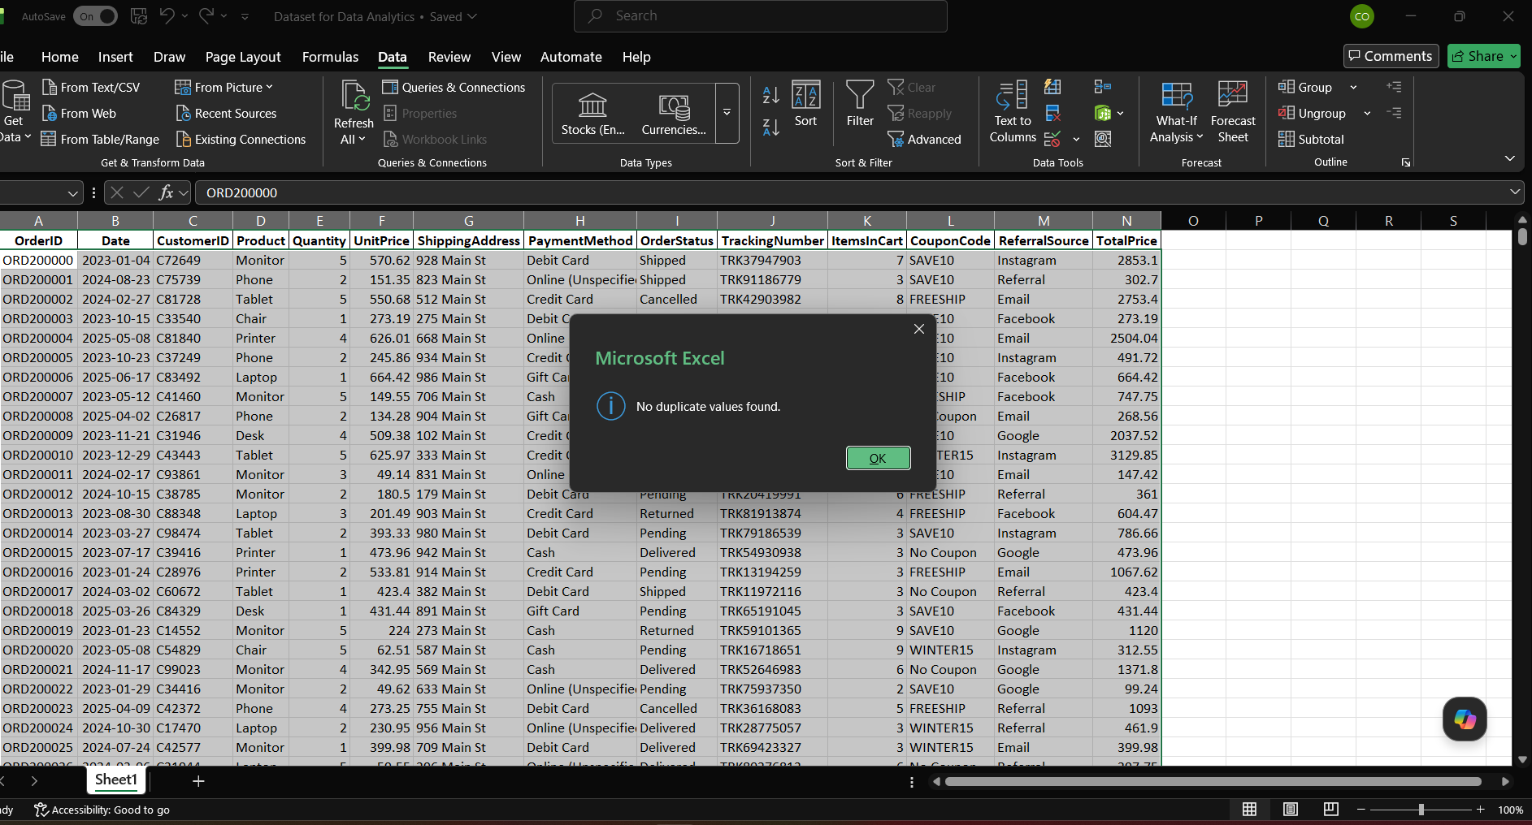
Audit Summary
Total Issues Found: 3
Total Issues Resolved: 3
Total Rows Affected: 567 (309 + 258)
Duplicate IDs Found: 0 (0% Error Rate) ✅
Date Format Errors Found: 0 (0% Error Rate) ✅
Final Dataset Status: CLEAN (Ready for Analysis)

Conclusion
This dataset has been cleaned and verified to meet the given standards. All null values were handled properly, all duplicate IDs were confirmed absent, and all date formats were confirmed to be consistent and correct. The dataset is now production-ready for further analysis and modeling.

